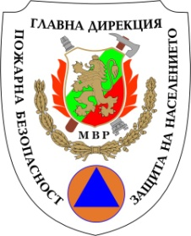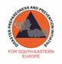

Republic of Bulgaria Disaster Preparedness and
MINISTRY OF INTERIOR Prevention Initiative for General Directorate Fire Safety and Civil Protection South-Eastern Europe (DPPI SEE)

EU ModEX exercises – opportunity for enhancement preparedness for disaster response

Registration Form

Deadline for registration: 2nd March 2018

Family name: |  |  |  |  | First name:
Male/Female:
Country:
Organisation:
Position:
Address:
Phone: |  |  |  | Fax:
E-mail:
Do you need an invitation letter for obtaining a visa? |  |  |  |  |  |  | Yes No
Title of your presentation during the seminar

ARRIVAL DATA
Date: |  |  | Time: |  |  |  |  | Place of arrival:
Transport type:
Plane | Flight number: |  |  |  |  | From:
Train | Train number: |  |  |  |  | From:
Car |  |  |  |  |  | Type and plate number:

DEPARTURE DATA
Date: |  |  | Time: |  |  |  |  | Place of departure:
Transport type:
Plane | Flight number: |  |  |  |  | From:
Train | Train number: |  |  |  |  | From:
Car
Special dietary or other requirements:
Request for reimbursement of travel expenses (accordingly to DPPI SEE Reimbursement policy) | Yes  No 

Please fulfill the Registration Form and send it back via e-mail until 2nd March 2018 to the points of contact below:

Points of Contacts:  DPPI SEE Secretariat  Mrs.Vildana Bijedic  Phone: +387 33 218 558  Mob: +387 63 892 486  E-mail: vildana.bijedic@dppi.info | Host country  Fire Safety and Civil Protection Chief Directorate – MoI  Ms. Evgeniya Vladimirova  Phone: +3592 960 10 243  E-mail: evladimirova@mvr.bg  Mrs. Antoaneta Peneva  Phone: + 3592 960 10 293  E-mail: appeneva@mvr.bg

